Class: COMP 3090 - Database I

Name: DangNhi Ngoc Ngo

Email: DangNhi_Ngo@student.uml.edu

Student ID: 01553277

**HOMEWORK #3**

**Exercise 2.4.3:**

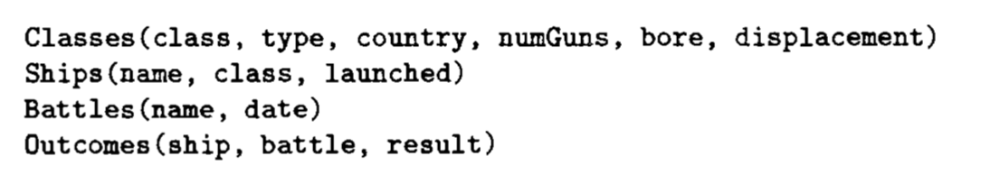

**a) Give the class names and countries of the classes that carried guns of at least 16-inch bore**

$${R1 :=}_{class,country}({}_{bore 16}\left(Classes\right))$$

Result of the query:

|  |  |
| --- | --- |
| class | country |
| Iowa | USA |
| North Carolina | USA |
| Yamato | Japan |

**b)** **Find the ships launched prior to 1921**

$${R1 :=}_{name}({}_{launched < 1921}\left(Ships\right))$$

Result of the query:

|  |
| --- |
| name |
| Haruna |
| Hiei |
| Kirishima |
| Kongo |
| Ramillies |
| Renown |
| Repulse |
| Resolution |
| Revenge |
| Royal Oak |
| Royal Sovereign |
| Tennessee |

**c) Find the ships sunk in the battle of the Denmark Strait**

$${R1 :=}_{ship}({}_{battle=’\text{Denmark Strait}’ result=’sunk’ }\left(Outcomes\right))$$

Result of the query:

|  |
| --- |
| ship |
| Bismarck |
| Hood |

**d) The treaty of Washington in 1921 prohibited capital ships heavier than 35,000 tons. List the ships that violated the treaty of Washington**

$${R1 :=}_{name}\left(Classes { ⋈}_{(displacement > 35000 launched >1921)}Ships\right)$$

Result of the query:

|  |
| --- |
| name |
| Iowa |
| Missouri |
| Musashi |
| New Jersey |
| North Carolina |
| Washington |
| Wisconsin |
| Yamato |

**e)** **List the name, displacement, and number of guns of the ships engaged in the battle of Guadalcanal**

$${R1 :=}_{R1\left(name,battle,result\right)}(Outcomes)$$

$${R2 :=}_{name,displacement,numGuns}((_{battle= ’Guadalcanal’}\left(R1)) ⋈Ships⋈Classes\right)$$

Result of the query:

|  |  |  |
| --- | --- | --- |
| name | displacement | numGuns |
| Kirishima | 32000 | 8 |
| South Dakota |  |  |
| Washington | 37000 | 9 |

**f) List all the capital ships mentioned in the database**

$${R3 :=}_{R1\left(capitalShip\right)}({}_{name}(Ships)){ }_{R2\left(capitalShip\right)}({}_{ship}(Outcomes))$$

Result of the query:

|  |
| --- |
| capitalShip |
| Arizona |
| Bismarck |
| California |
| Duke of York |
| Fuso |
| Hood |
| King George V |
| Kirishima |
| Prince of Wales |
| Rodney |
| Scharnhorst |
| South Dakota |
| Tennessee |
| Washington |
| West Virginia |
| Yamashiro |
| California |
| Haruna |
| Hiei |
| Iowa |
| Kirishima |
| Kongo |
| Missouri |
| Musashi |
| New Jersey |
| North Carolina |
| Ramillies |
| Renown |
| Repulse |
| Resolution |
| Revenge |
| Royal Oak |
| Royal Sovereign |
| Tennessee |
| Washington |
| Wisconsin |
| Yamato |

**g)** **Find the classes that had only one ship as a member of that class**

$${R1 :=}_{R1}\left({}_{name,class}\left(Ships\right)\right)$$

$${R2 :=}_{R2}({}_{name,class}(Ships))$$

$${R3 :={}_{class}\left(Classes\right)-}_{class}\left(R1 { ⋈}_{(R1.class=R2.class R1.name<> R2.name)}R2\right)$$

Result of the query:

|  |
| --- |
| class |
| Bismarck |

**h) Find those countries that had both battleships and battlecruisers**

$${R1 :=}_{country}({}_{type= ’bb’}\left(Classes\right)){ }_{country}({}_{type= ’bc’}\left(Classes\right))$$

Result of the query:

|  |
| --- |
| country |
| Japan |
| Gt. Britain |

**i)** **Find those ships that “lived to fight another day”; they were damaged in one battle, but later fought in another**

$${R1 :=}_{R1\left(ship,battle,result\right)}\left(Battles { ⋈}_{(name=battle)}Outcomes\right)$$

$${R2 :=}_{R2(ship,battle,result)}\left(Battles { ⋈}_{(name=battle)}Outcomes\right)$$

$${R3 :=}_{ship}\left(R1{ ⋈}_{(R1.ship=R2.ship R1.result=’damaged’ R1.date <R2.date )}R2 \right)$$

Result of the query:

|  |
| --- |
| ship |
| Prince of Wales |
| South Dakota |